Aspoo Bricks

Table of Contents
Aspoo M0002 Brick 3
Module overview 3
Hardware 3
Pinout 3
Circuit diagram 4
Programming Aspoo M0002 Brick with Arduino 5
Led blinking 5
Switch simple program 6
DS18B20 temperature read 7
WiFi Acces Point 9
Configure Arduino 10
Work with ESP8266 10

Aspoo M0002 Brick

Module overview
Aspoo M0002 Brick is an electronic WiFi module designed to operate the DS18B20 sensor. The module was built based on the ESP8266 chipset.
The module features:
- WiFi interface
- programming interface
- connector for DS18B20 sensor
- universal button
- programmable LED
- power indicator LED
The module can be programmed using the Arduino environment.

Hardware

Pinout
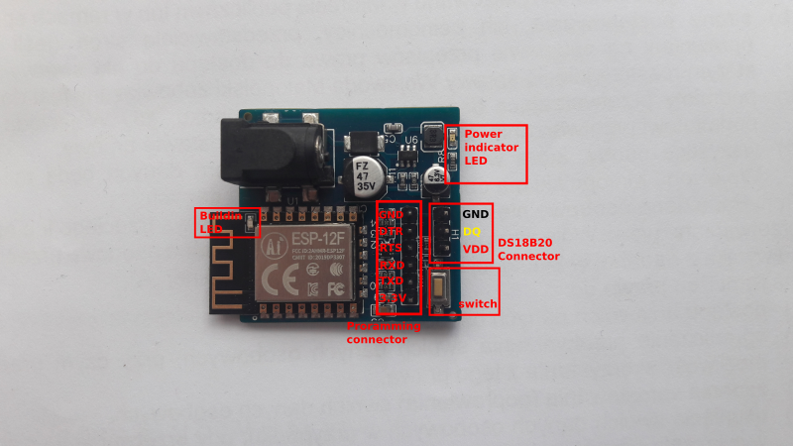
- DS18B20 DQ is connected to GPIO4 pin
- switch is connected to GPIO0 pin
- buildin LED is connected to GPIO2 pin

Circuit diagram
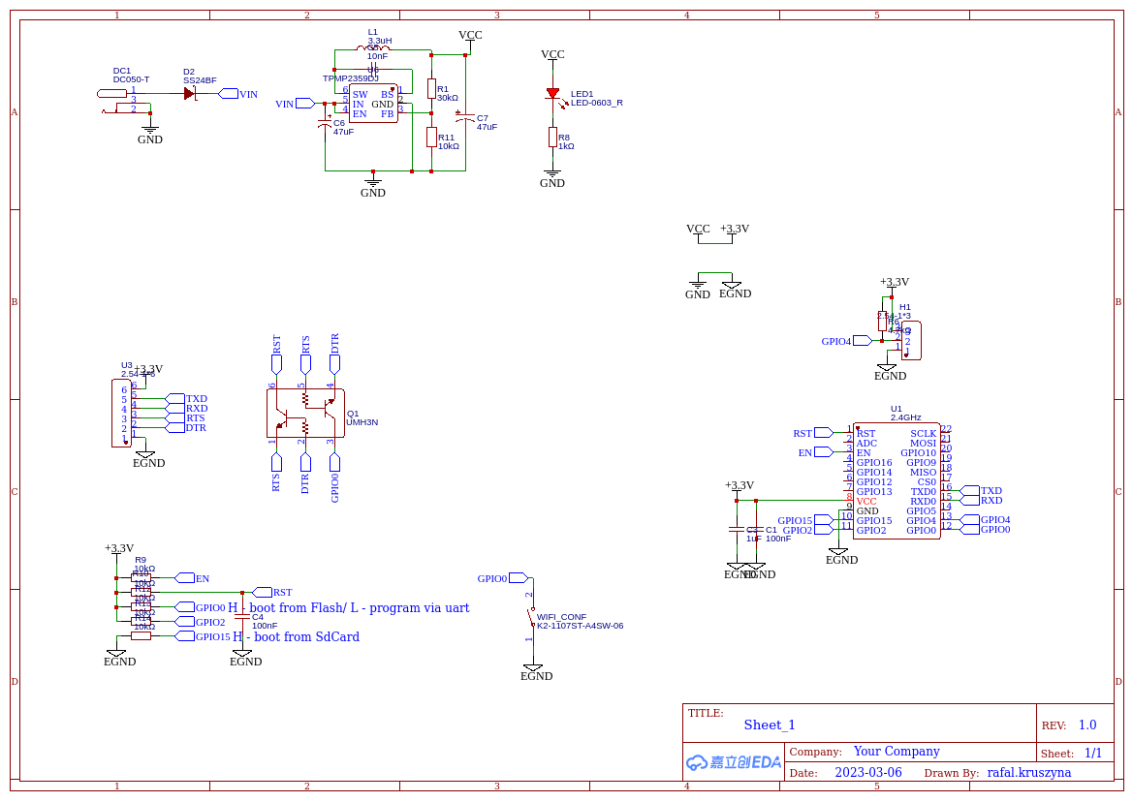

Programming Aspoo M0002 Brick with Arduino

Led blinking
Sample arduino program for Aspoo M0002 module blinking the built-in LED. The LED is connected to GPIO2 pin.

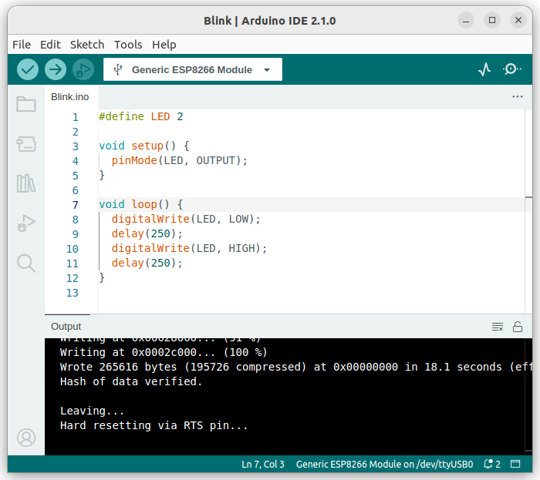

Switch simple program
Sample Arduino program for Aspoo M0002 module, illuminating the built-in LED when the button is pressed. The button is connected to GPIO0 pin, and the LED is connected to GPIO2 pin.

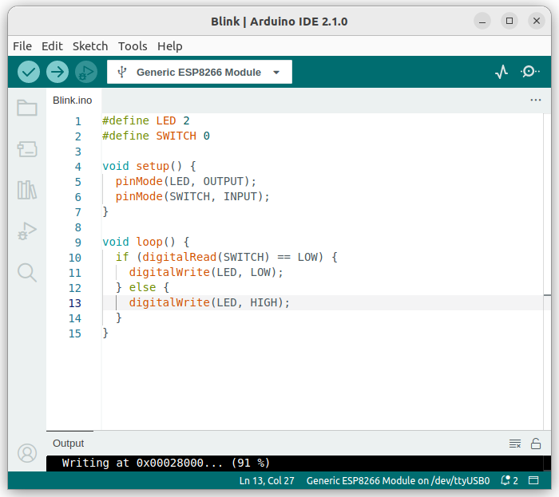

DS18B20 temperature read
Below is the Arduino program that reads temperature from the DS18B20 sensor using the Aspoo M0002 module. The temperature is displayed on the console. The sensor is connected to GPIO4 pin. To run the program, you need to install two libraries, OneWire and DallasTemperature and set SerialMonitor speed to 9600b/s.

Install OneWire library:
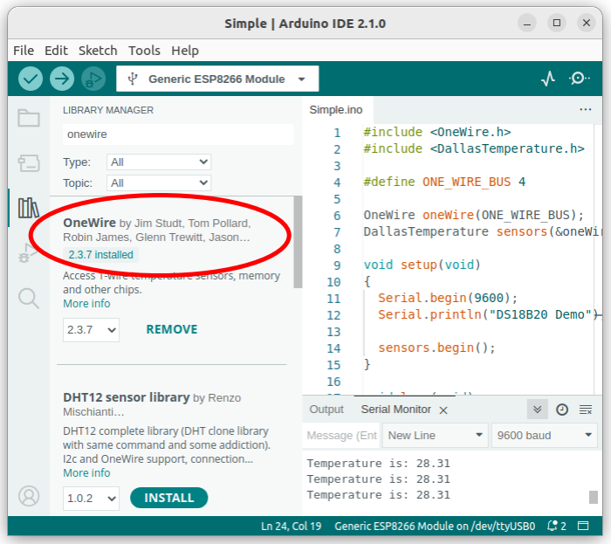

Install DallasTemaperature library:
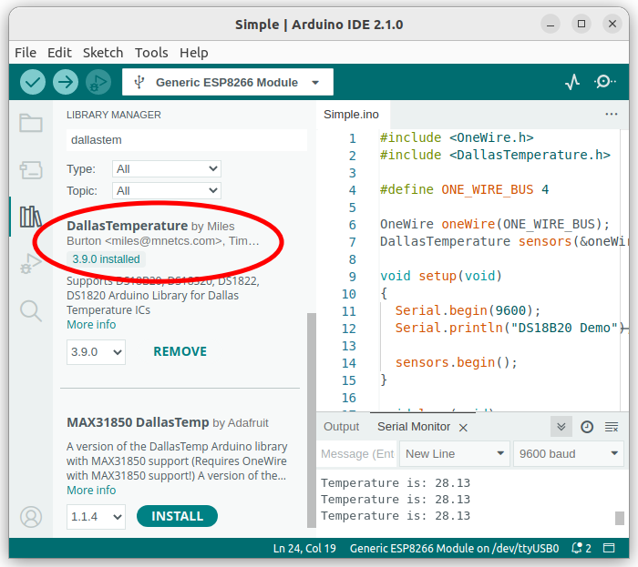

Run DS18B20 program on Aspoo M0002 brick:
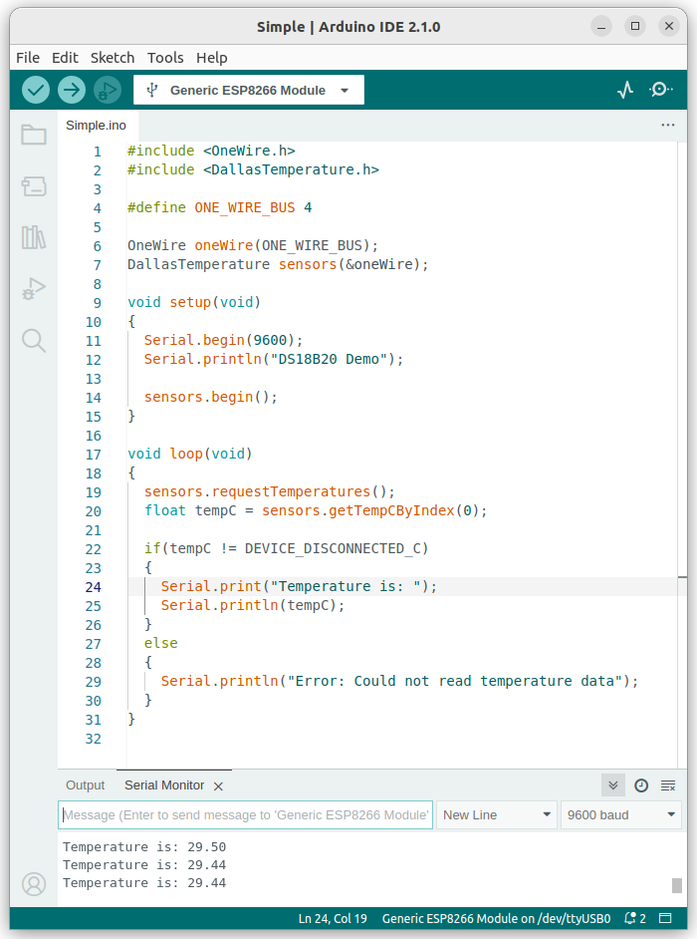

WiFi Acces Point
A simple example of how to check the WiFi functionality on the Aspoo M0002 module. The program creates a network named "TestNetwork," and connecting to the network requires the password "12345678." After connecting to the network, you can open a web browser and go to the page http://192.168.4.1.

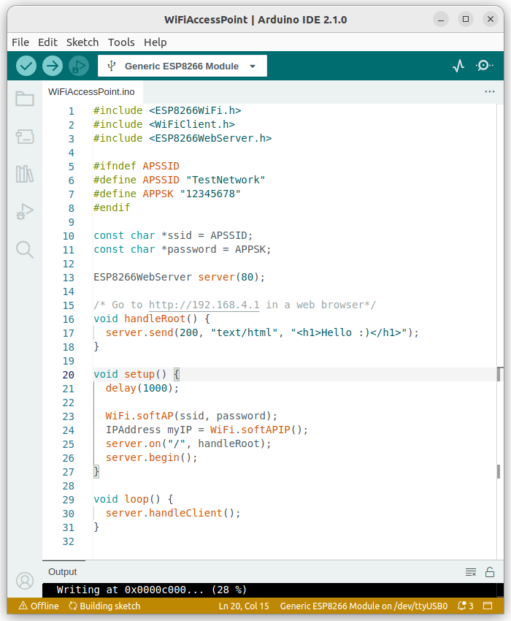

Configure Arduino

Work with ESP8266
To use the ESP8266 with Arduino, you need to install the necessary packages. The detailed instructions can be found on the website https://github.com/esp8266/Arduino in the "Installing with Boards Manager" section.The entire operation boils down to launching Arduino IDE, accessing the "File->Preferences..." menu, and pasting the appropriate link into the "Additional boards manager URLs" field, as shown in the image below.

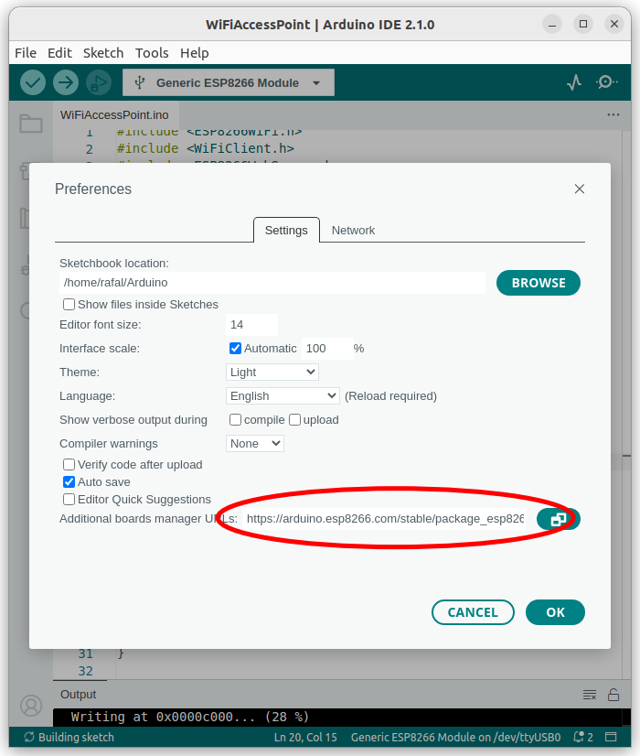

The next step is to select the board. We go to the menu and choose "Tools->esp8266->Generic ESP8266 Module." Selecting the appropriate option will be visible in the program as shown in the image below.

